Components:

1. PM2.5 GP2Y1010AU0F:

S.no. | Sensor | Connections
1. | V-LED | 5V External Power Supply (with 150 ohm resistor)
2. | LED-GND | Common ground
3. | LED | ESP-32 GPIO pin
4. | S-GND | Common ground
5. | Vo | ESP-32 GPIO pin
6. | VCC | 5V External Power Supply

INPUT CONDITION FOR LED INPUT TERMINAL (fig 1. from datasheet)

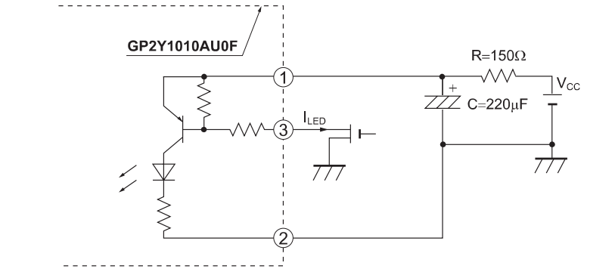
Characteristics:
Parameter | Symbol | Min | Avg | Max | Unit
LED current | ILED | — | 10 | 20 | mA
Consumption Current | ICC | — | 11 | 20 | mA
Sensitivity | K | 0.35 | 0.5 | 0.65 | V/(0.1mg/m³)
Output voltage at no dust | VOC | 0 | 0.9 | 1.5 | V

2. MQ-135 Gas Sensor:

S.no. | Sensor | Connections
1. | VCC | 5V external power
2. | GND | Common Ground
3. | DO (Digital output) | NIL
4. | AO (Analog output) | ESP-32 GPIO

